STUDENT FEE RECEIPT PORTAL
@CREATIVITY THINK (9483175986/7019689991)

ABSTRACT:
The Student Fee Receipt Portal is a web-based system designed to streamline fee management for schools, colleges, and coaching centers. The platform allows students and parents to view fee structures, submit offline payment references, and receive verified digital receipts in PDF format. Administrators can set fee structures, verify payments, track paid and pending fees, generate reports, and send reminders. Developed using Django and Django REST Framework for backend operations, and React with axios and pdfkit for frontend and PDF generation, the system ensures efficient, transparent, and reliable fee management..

INTRODUCTION OF THE PROJECT:
Managing student fees manually or through traditional methods can be prone to errors, delayed verification, and lack of transparency. Offline payment tracking and receipt issuance require significant administrative effort, often leading to miscommunication with students and parents. The Student Fee Receipt Portal addresses these challenges by providing a digital platform for fee structure display, offline payment verification, receipt generation, and historical tracking. Real-time analytics and structured workflows ensure efficient fee collection and reporting..

PROJECT OBJECTIVES:

• Display fee structures per class, course, or program
• Allow students and parents to submit offline payment references
• Verify payments and generate PDF receipts for records
• Track payment status (paid/pending) and history
• Provide dashboards with analytics for fee collection and pending payments
• Send automated reminder notifications for pending fees
• Export collection reports for administrative review
• Ensure secure, reliable, and transparent fee management
• Support scalability for multiple classes and courses

PROBLEM OF THE STATEMENT:
Institutions often face challenges in fee collection due to manual processing, offline payments, and lack of centralized tracking. Students and parents may not receive timely confirmations, leading to disputes. Administrators face difficulties in verifying payments, generating receipts, and maintaining historical records. The Student Fee Receipt Portal solves these problems by offering a digital platform to manage fee structures, verify payments, issue receipts, track status, and provide analytics in a streamlined manner..

MOTIVATION OF THE PROJECT:
• To digitize fee collection and receipt generation
• To minimize errors in payment tracking and verification
• To improve communication with students and parents regarding fees
• To enable easy generation of receipts in PDF format
• To provide real-time insights into fee collection and pending payments
• To reduce administrative workload and manual effort
• To ensure transparent and accountable financial operations
• To provide a secure and user-friendly platform for institutions

BLOCK DAIGRAM OF PROJECT:

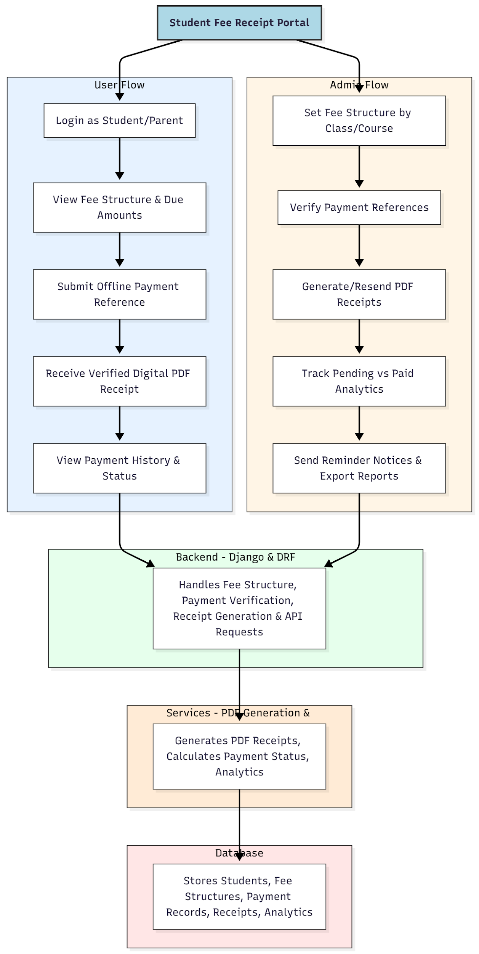

WORKING OF THE PROJECT:
Students or parents log in to the portal to view the fee structure and pending amounts. They submit offline payment references for cash or bank payments, which are then verified by administrators. Upon verification, a digital receipt is generated in PDF format and made available to the user. Users can view the history of all payments and track status. Administrators can manage fee structures for different classes or courses, resend receipts, track analytics of collected versus pending fees, send reminders, and export reports. The backend ensures secure handling of data, payment verification, receipt generation, and analytics processing, while the frontend provides an interactive and responsive interface..

SOFTWARE REQUIREMENT:
- Backend:
  - Python 3.x
  - Django
  - Django REST Framework
  - SQLite/PostgreSQL
- Frontend:
  - Node.js and npm
  - React.js
  - Axios
- Development Tools:
  - Visual Studio Code
  - Postman (for testing APIs)
  - Git/GitHub (for version control)
- Server/Deployment (Optional):
  - Gunicorn, Nginx, or Heroku/AWS for hosting

ADVANTAGES OF THE PROJECT:

• Streamlines fee management for institutions
• Provides verified digital receipts in PDF format
• Tracks pending and paid fees efficiently
• Reduces administrative workload and manual errors
• Enhances communication with students and parents
• Generates analytical reports and reminders for better planning
• Maintains historical payment records
• Secure, reliable, and scalable for multiple courses and classes

APPLICATIONS OF THE PROJECT:
• Schools
• Colleges
• Coaching centers
• Training institutes
• Any educational institution with structured fee collection

REFERENCES:

- Django REST Framework Documentation — Django Software Foundation. Django Documentation. Available: https://docs.djangoproject.com/
- Django REST Framework. DRF Documentation. Available: https://www.django-rest-framework.org/
- React. React Official Documentation. Available: https://reactjs.org/docs/getting-started.html
- Redux. Redux Documentation. Available: https://redux.js.org/introduction/getting-started
- PostgreSQL Global Development Group. PostgreSQL Documentation. Available: https://www.postgresql.org/docs/
- MySQL. MySQL Reference Manual. Available: https://dev.mysql.com/doc/
- Git. Git Documentation. Available: https://git-scm.com/doc
- Node.js. Node.js Documentation. Available: https://nodejs.org/en/docs/
- Axios. Axios Documentation. Available: https://axios-http.com/docs/intro
- Socket.io Documentation – https://socket.io/docs/

